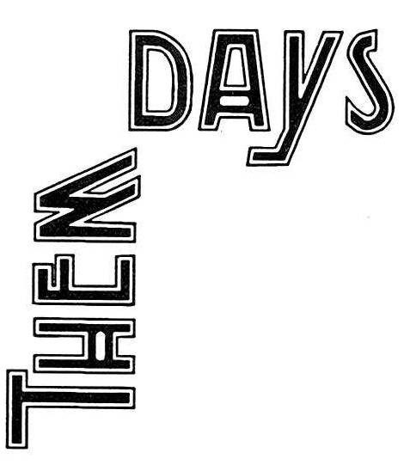 | Height of Land Challenge
 | June 2021
 | Kilometre tracker

Join us on our Height of Land Challenge!
Many trappers canoed from North West River to the Height of Land, past the Grand Falls (now named Churchill Falls) and spent a lot of time walking on their traplines before heading home on foot over the frozen river with a load of furs. Get a taste of their physical ability by joining us on a virtual walk from North West River to the Height of Land and back! Track your kilometres walked, and email your weekly totals to themdays@themdays.com.

Sunday | Monday | Tuesday | Wednesday | Thursday | Friday | Saturday | SUBTOTALS
 |  | 1 | 2 | 3 | 4 | 5
6 | 7 | 8 | 9 | 10 | 11 | 12
13 | 14 | 15 | 16 | 17 | 18 | 19
20 | 21 | 22 | 23 | 24 | 25 | 26
27 | 28 | 29 | 30
 |  |  | END!! SEND IN YOUR TOTALS!

